Creating a Graduate School Application Account & Applying on the
UNC-Charlotte Graduate School Application Portal

- Go to http://mygradschool.uncc.edu

- Select “Create My Account”

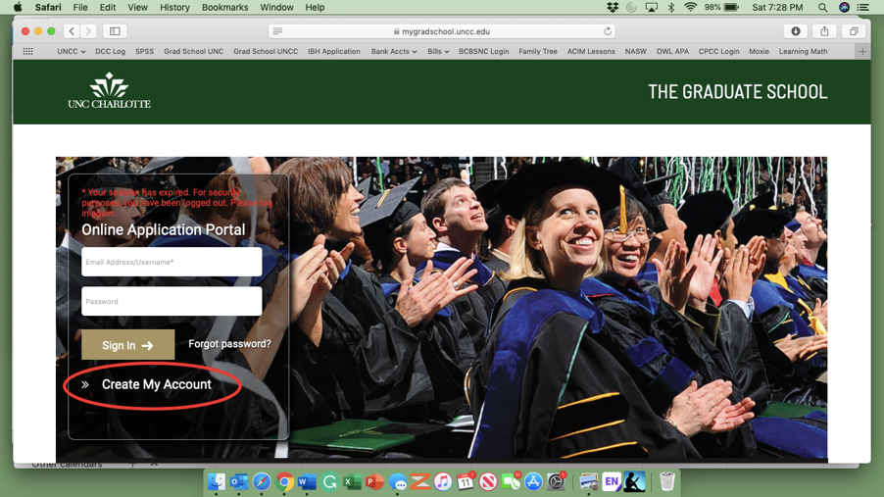

- Insert “Personal Information”

- Under “Enrollment Plans” select the term you plan to take your course during and Postbaccalaureate as your enrollment type. For intended major, select Post-Baccalaureate – Non-degree (UNDG)

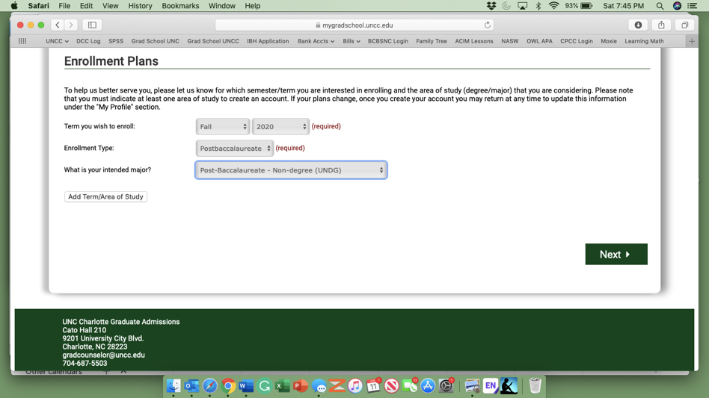

- Select “Next”

- Insert “Primary Contact Information” and select “Next”

- Confirm information and select “Create Account”

- You should receive an email from the UNC Charlotte Graduate School. Select “Confirm Account”
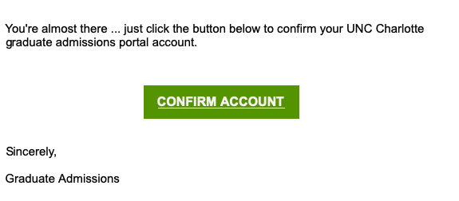

- Verify email address, create password, and select “Confirm Account”

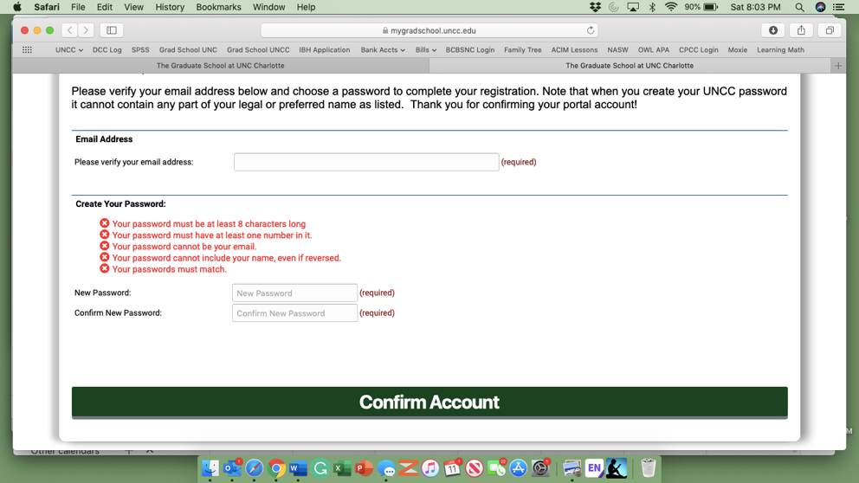

- Under “My Applications” select “Apply to Graduate School”

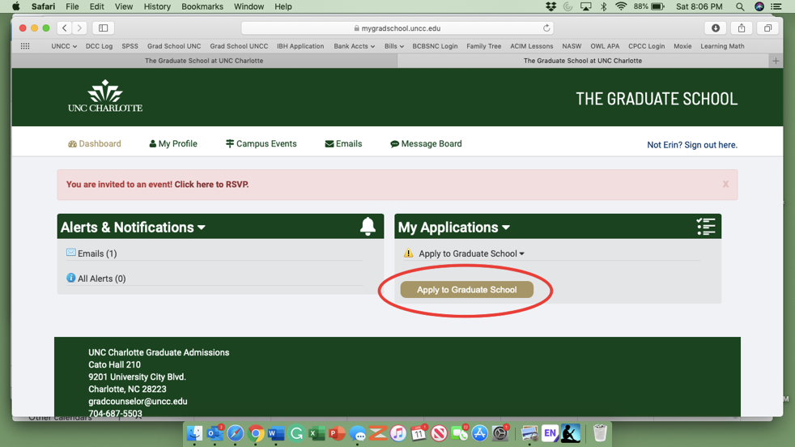

- Step 1: Select “Postbaccalaureate”

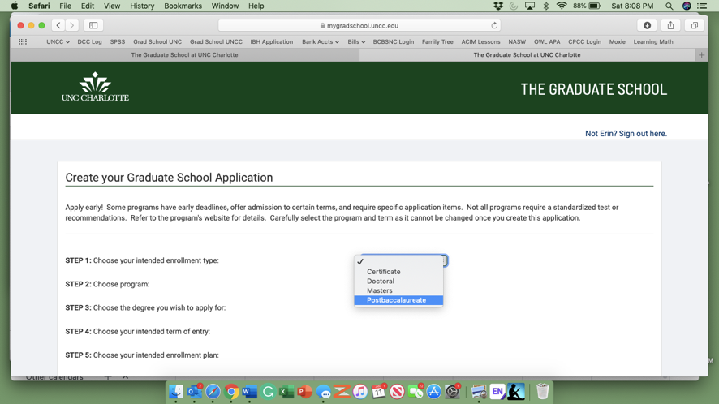

- Step 2: Select “Post-baccalaureate – Non-degree”

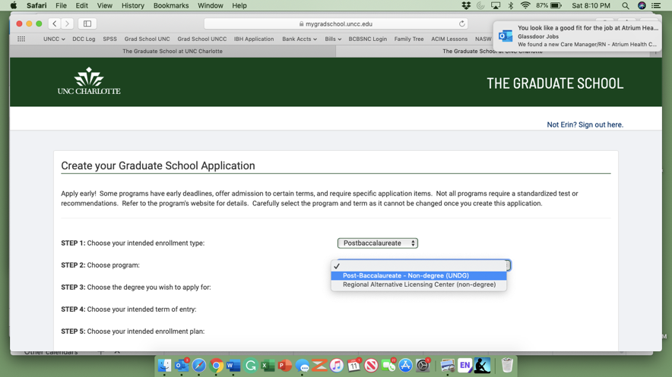

- Step 4: Select term you will enroll in “Summer 2020”

- Step 5: Select “Part-time”

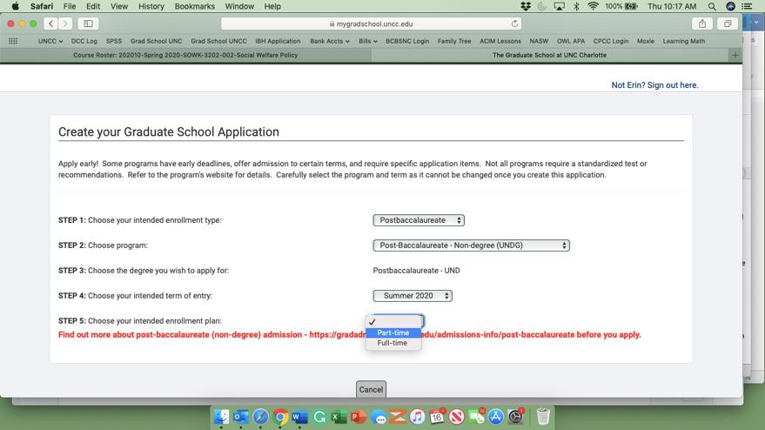

- Select “Create Application”

- You will be rerouted to the application page. Fill out all pages (General Information, Contact Information, Demographic Information, Education Information, Work History, Campus Safety, Military Service, Additional Information, Application Fee). We recommend “Saving Changes” on each page.

- NORTH CAROLINA RESIDENTS – At the bottom of the “General Information” page, you will be asked to provide your Residency Certification Number. To obtain this number, visit www.ncresidency.cfnc.org – Select “Complete Residency Confirmation”

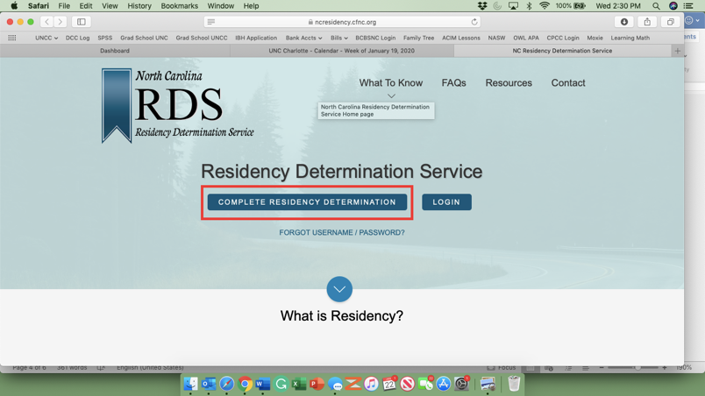

- You will be prompted to create an account and provide information to prove residency. Students who qualify for in-state tuition will receive an RCN #. Input this number on your UNCC application.

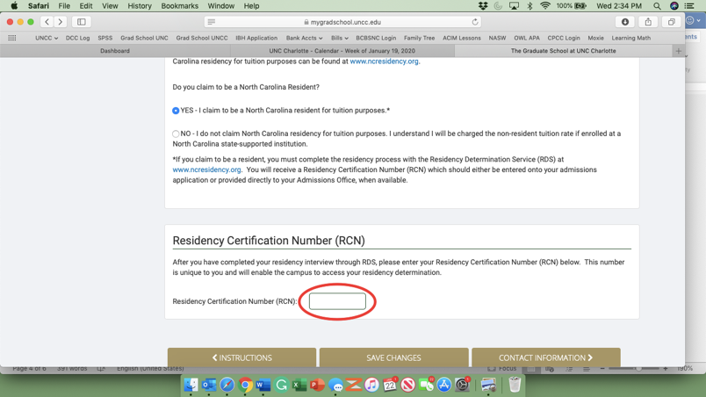

- On “Additional Information” you DO NOT need to select a program that you are affiliated with

- Once all information is complete, hit “Submit”

You will be notified by email once your application is processed. Once admitted, you will also receive a student identification number (commonly referred to as an 800 number) and instructions for creating a NinerNet account.
Registering For Class Through Banner-Self-Serve

- Go to www.my.uncc.edu to login in to your NinerNet account.

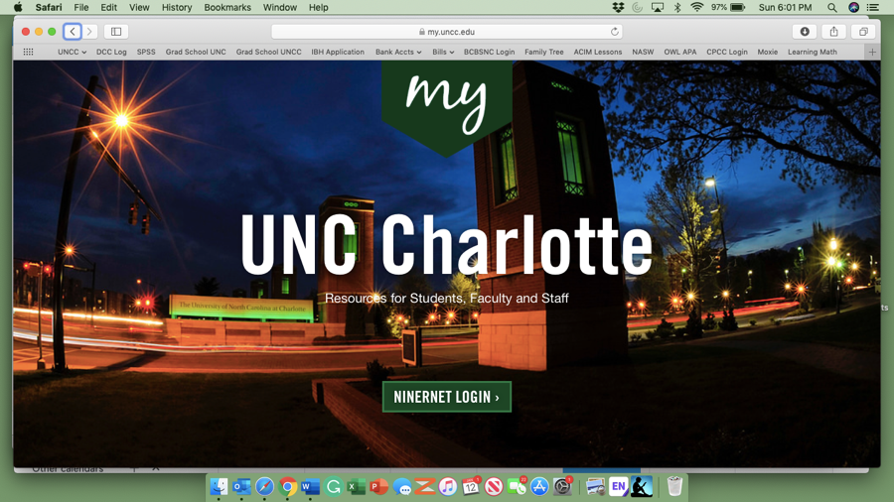

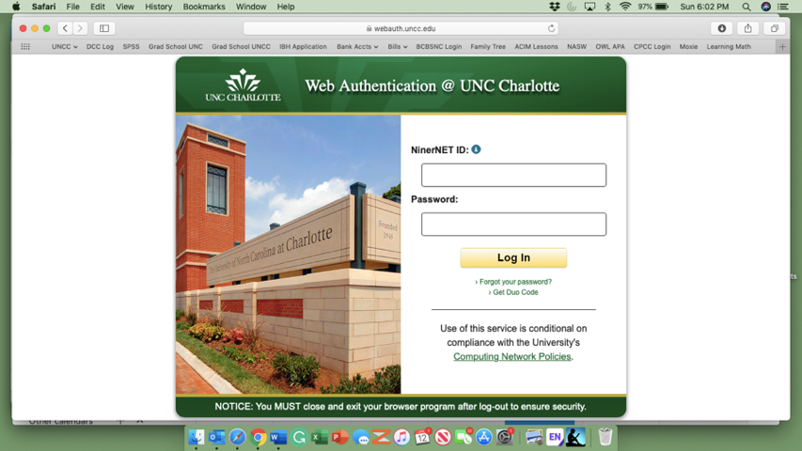

- Once logged in, on the right hand side of the screen you will see a box labeled “Quick Links.” Select the “Banner Self Service” Icon.

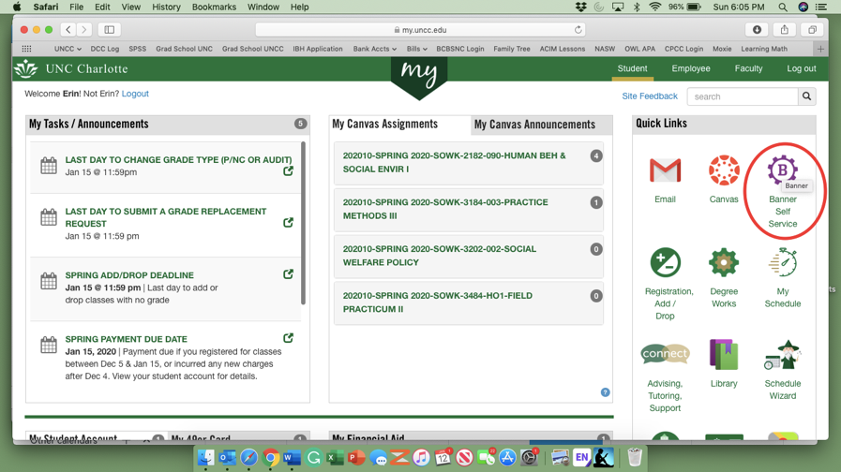
- Select “Student Services/Student Accounts”

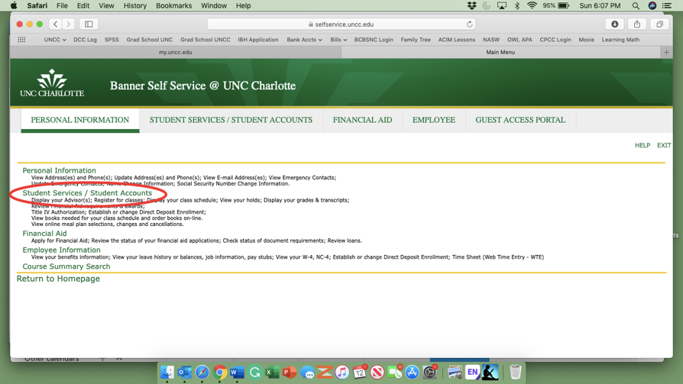

- Select “Registration”

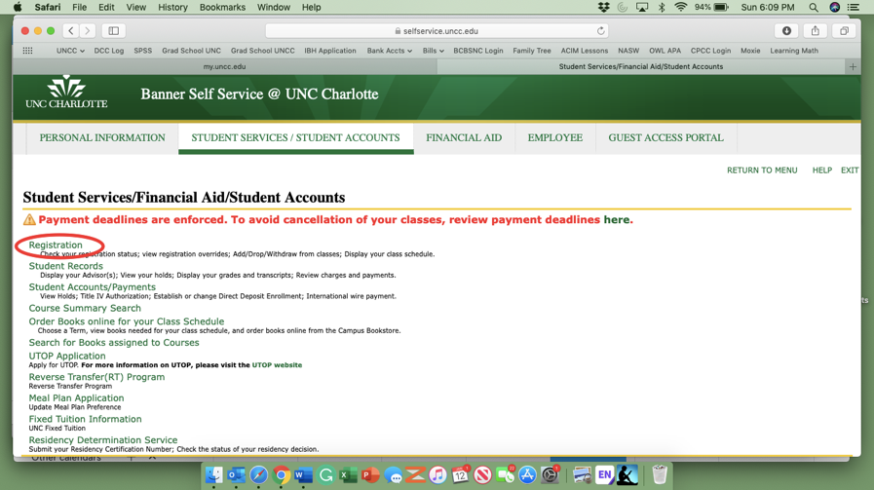

- Select “Add/Drop/Withdraw Classes”

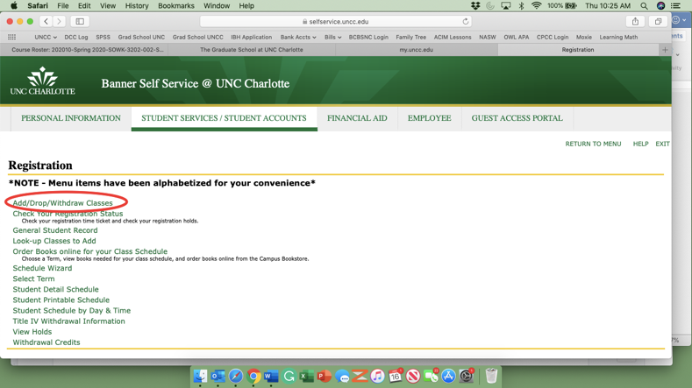

- Select Term “Summer 2020”

- Under “Add Classes Worksheet” input the CRN (Course Registration Number) 30013 and click “submit changes”

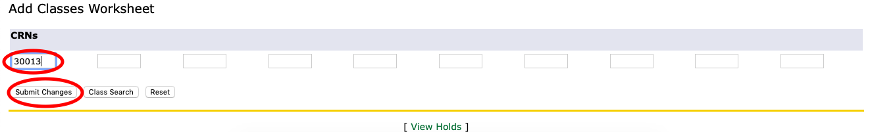

- You should now see your School Social Work course listed as Web Registered under Current Schedule. No further action is necessary.

